DE–4056
13
DISTANCE EDUCATION
B.Sc. (Mathematics) DEGREE EXAMINATION,
DECEMBER 2008.
CLASSICAL ALGEBRA
Time : Three hours Maximum : 100 marks
Answer any FIVE questions.
All questions carry equal marks.
- (a) Show that a sequence cannot converge to two distinct limits.
(b) If 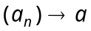 and 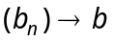, then show that 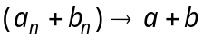.
(c) Show that 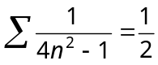.
- (a) Test the convergence of the following series :
(i) 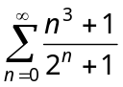
(ii) 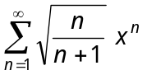
(b) State and prove Cauchy's root test.
- (a) Find the sum to infinity of the series.
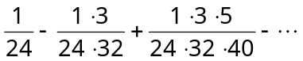
(b) State and prove exponential theorem.
- (a) Sum the series
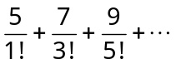
(b) Show that
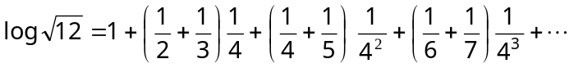
(c) Prove that
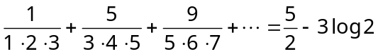.
- (a) Solve 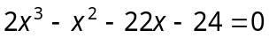, two of the roots being in the ratio 3 : 4.
(b) If 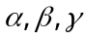 are the roots of 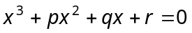, find the value of 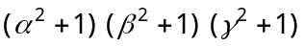.
(c) Show that the sum of the nineth powers of the roots of 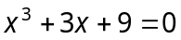 is zero.
- (a) Increase by 7 the roots of the equation 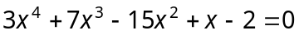.
(b) Solve the equation.
by removing its second term.
(c) Find the condition that the equations 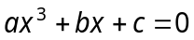 and 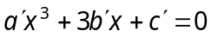 should have a common root.
- (a) Show that
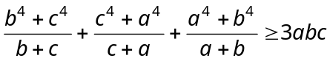
(b) Show that
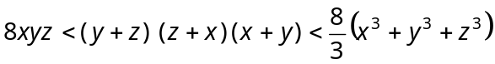
(c) Prove that the arithmetic mean of n positive quantities which are not equal to one other is greater than their geometric mean.
- (a) Show that
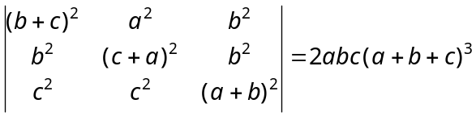.
(b) Solve the following system of equations :
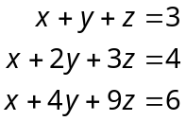
(c) Find the eigen values of the matrix.
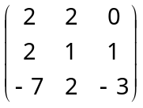
———————
DE–4057
14
DISTANCE EDUCATION
B.Sc. (Mathematics) DEGREE EXAMINATION,
DECEMBER 2008.
CALCULUS
Time : Three hours Maximum : 100 marks
Answer any FIVE questions.
All questions carry equal marks.
1. (a) If 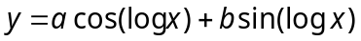 P.T
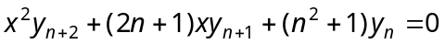.
(b) If 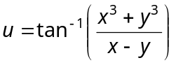 P.T 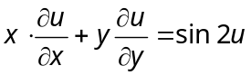.
2. (a) Find the equation of the tangent to the curve 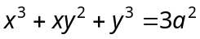 at the point (a, a).
(b) Find the radius of curvature of 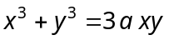 at the point 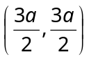.
3. (a) Evaluate 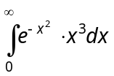
(b) Evaluate 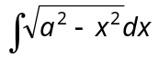.
4. (a) Evaluate 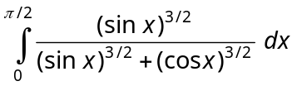.
(b) Obtain the reduction formula for 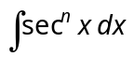.
5. (a) Solve 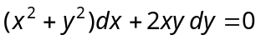
(b) Solve 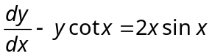.
6. (a) Solve 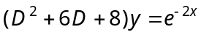
(b) Solve 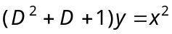.
7. (a) Find 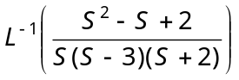.
(b) Using laplace transformation solve
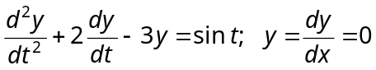 when t = 0.
8. (a) Eliminate the arbitrary functions f and φ from the relation 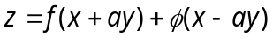.
(b) Find the complete Integral by using Charipts method 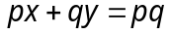.
————————
DE–4058
15
DISTANCE EDUCATION
B.Sc. (Mathematics) DEGREE EXAMINATION,
DECEMBER 2008.
ANALYTICAL GEOMETRY AND VECTOR CALCULUS.
Time : Three hours Maximum : 100 marks
Answer any FIVE questions.
All questions carry equal marks.
1. (a) Find the angle between the straight lines whose direction cosines are given by the relation 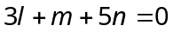 and 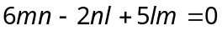 .
(b) Find the angle between the two diagonals of a cube.
2. (a) Find the equation of the plane through the line of intersection of the two planes 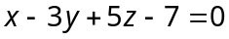 and 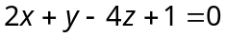 and perpendicular to the plane 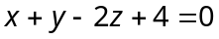.
(b) Find the equation of the plane through the intersection of the planes 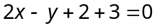 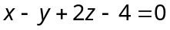 and which is at a distance 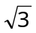 from the origin.
3. (a) Find the Co-ordinates of the image of a point 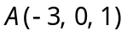 in the plane .
(b) Show that the equation
.
represents a pair of planes and find the angle between them.
4. (a) Find the symmetrical form of the equations of the straight line and find the point where the line intersects the plane 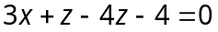.
(b) Show that the lines.
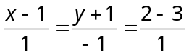 and 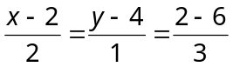
are co-planar and find their point of intersection. Find also the equation of the plane containing them.
5. (a) Find the length and the equations of the shortest distance between the lines 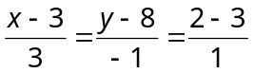 and 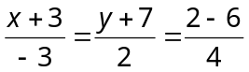.
(b) Find the equation of the sphere passing through
the origin and cutting off positive intercepts 5, 7, 9 on the
co-ordinate axes.
6. (a) Find the equation of the sphere passing through the points (4, –1, 2), (0, –2, 3), (1, –5, –1) (2, 0, 1).
(b) Find the centre and radius of the circle in which the sphere 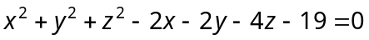 is cut by the plane 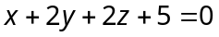.
7. (a) Prove that
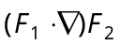.
(b) If 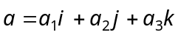 and 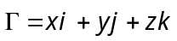 show that 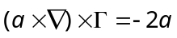.
8. (a) Verify hangs divergence theorem if 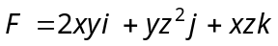 and S is the total surface of the rectangular parallelepiped bounded by the planes .
(b) Evaluate 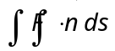 over the sphere 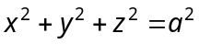, where 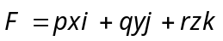.
————————
DE–4059
23
DISTANCE EDUCATION
B.Sc. DEGREE EXAMINATION, DECEMBER 2008.
Mathematics
MECHANICS
Time : Three hours Maximum : 100 marks
Answer any FIVE questions.
(5 × 20 = 100)
1. (a) Prove that if three jokes acting at a point are in equilibrium then any triangle drawn so as to have its sides parallel to the directions of the jokes shall represent them in magnitude also.
(b) A, B, C are three points on the circumference of a circle and jokes P and Q act along AB and BC respectively. If their resultant is a joke R along the tangent at B, show that 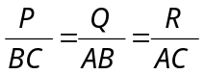.
2. (a) Derive the equation to the line of action of the resultant.
(b) Forces 3, 2, 4, 5 kg. wt. act respectively along the sides AB, BC, CD and DA of a square. Find the magnitude of their resultant and the point where its line of action meets AB and AD.
3. (a) Write the condition of equilibrium of three coplanar parallel forces.
(b) Three line parallel jokes acting at the vertices of a triangle, have magnitudes proportional to the opposite sides. Show their resultant passes through the incentre of the triangle.
4. (a) Explain the terms statical, law of dynamical friction, cone of friction.
(b) A weight can be supported on a rough inclined plane by a force P acting along the plane or by a force Q acting horizontally. Show that the weight is 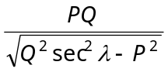 where
is the angle of friction.
5. (a) Show that the path of a projectile (in Vacuo) is a parabola.
(b) If the greatest height attained by the particle is a quarter of its range on the horizontal plane through the point of projection, find the angle of projection.
6. (a) A gun of mass M fires a shell of mass m horizontally and the energy of the explosion is such as would be sufficient to project the shell vertically to a height h. Show that the velocity of the horizontal recoil V of the gun is given by 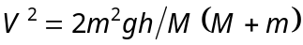.
(b) Three equal spheres are in a straight line on a table and one of them moves towards the other two which are at rest and not in contact. If 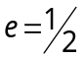. Show that there will be three impacts.
7. (a) Explain the Geometrical representation of a simple harmonic motion.
(b) A horizontal shelf moves vertically with S.H.M. whose complete period is one second. Find the greatest amplitude in centimetres, it can have, so that an object restring on the shelf may always remain in contact.
8. (a) Derive the pedal equation of circle pole at any point.
(b) Find the law of force towards the pole under which the curve 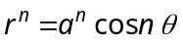 can be described.
—————————
DE–4060
24
DISTANCE EDUCATION
B.Sc. DEGREE EXAMINATION, DECEMBER 2008.
Mathematics
ANALYSIS
Time : Three hours Maximum : 100 marks
Answer any FIVE questions.
All questions carry equal marks.
1. (a) (i) Define a metric space and give an example.
(ii) Let 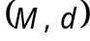 be a metric space. Define 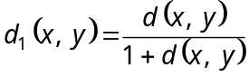. Prove that 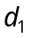 is a metric on M.
(b) Let be a metric space. Define
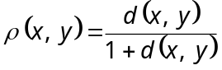. Prove that d and are equivalent metrices on M.
2. (a) (i) In any metric space each open ball is an open set.
(ii) In any metric space the intersection of a finite number of open sets is open.
(b) (i) Let be a metric space. Let 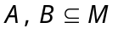 then prove that,
(1) 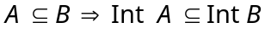
(2) 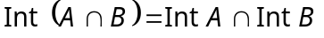
(3) 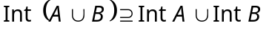
(ii) Let and 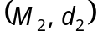 be two metric spaces. A function 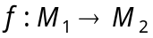 is continuous iff 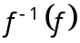 is closed in 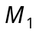 whenever f is closed in 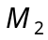.
3. (a) State and prove Cantor’s Intersection Theorem.
(b) State and prove Baire’s Category Theorem.
4. (a) A subspace of R is connected iff it is an interval.
(b) (i) Prove that any continuous image of a connected set is connected.
(ii) State and prove the intermediate value theorem.
5. (a) Define a compact metric space with an example.
(b) Any continuous mapping f defined on a compact metric space 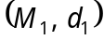 into any other metric space 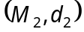 is uniformly continuous on .
6. (a) State and prove Heine Borel theorem.
(b) A metric space M is compact iff any family of closed sets with finite intersection property has non-empty intersection.
7. (a) State and prove the cauchy criterion for uniform convergence.
(b) State and prove weierstrass M-test.
8. (a) Let 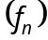 be a sequence in 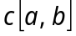. Let 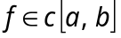 then converges to f in iff converges to f uniformly on 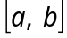.
(b) State and prove Piccard’s theorem.
———————
DE–4061
25
DISTANCE EDUCATION
B.Sc. (Mathematics) DEGREE EXAMINATION,
DECEMBER 2008.
PROBABILITY AND STATISTICS
Time : Three hours Maximum : 100 marks
Answer any FIVE questions.
Each question carries 20 marks.
1. (a) State and prove generalised Boole’s inequity.
(b) The chances that four students A, B, C, D solve a problem are 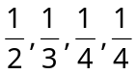 respectively. If all of them try to solve the problem independently, find the probability the problem is solved.
2. (a) Find the mean and variance of the first n natural numbers.
(b) If the function 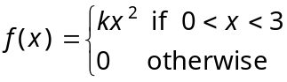
is a probability density function,
(i) Find the constant k
(ii) Compute 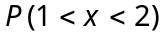
(iii) Find the distribution function.
3. (a) Fit a curve of form 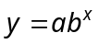 to the following data :
Year (x) : | 1951 | 1952 | 1953 | 1954 | 1955 | 1956 | 1957
Production (y) : | 201 | 263 | 314 | 395 | 427 | 504 | 612
(b) If r is the correlation coefficient between x and y, prove that 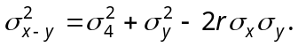
4. (a) Three judges X, Y, Z assign the following ranks to
8 entries in a beauty contest :
X : | 1 | 2 | 4 | 3 | 7 | 6 | 5 | 8
Y : | 3 | 2 | 1 | 5 | 4 | 7 | 6 | 8
Z : | 1 | 2 | 3 | 4 | 5 | 7 | 8 | 6
Which pair of judges have the nearest approach to the common taste in beauty?
(b) Ten students obtained the following marks in the college internal test (x) and in the final university examination (y) :
x : | 51 | 63 | 63 | 49 | 50 | 60 | 65 | 63 | 46 | 50
y : | 49 | 72 | 75 | 50 | 48 | 60 | 70 | 48 | 60 | 56
Estimate the university examination mark of a student who got 61 in the college internal test.
5. (a) (i) Find the moment generating function about the origin of the Binomial distribution
(ii) State and prove additive property of Binomial distribution.
(b) The distribution of typing mistakes committed by a typist is given below. Assuming a Poisson model, find the expected frequencies.
Mistakes per page : | 0 | 1 | 2 | 3 | 4 | 5
No. of pages : | 142 | 156 | 69 | 27 | 5 | 1
6. (a) Find the moment generating function of the normal distribution about the origin. Hence find its mean and variance.
(b) In a normal distribution, 31% of the items are under 45 and 8% are over 64. Find the mean and Standard Deviation.
7. (a) Ten soldiers were given an intensive training in shooting. Their scores in shooting competitions before and after the training were given below :
Soldier: | 1 | 2 | 3 | 4 | 5 | 6 | 7 | 8 | 9 | 10
Scores before (x) : | 67 | 24 | 57 | 55 | 63 | 57 | 56 | 68 | 33 | 43
Scores after (y) : | 70 | 38 | 58 | 58 | 56 | 67 | 68 | 75 | 42 | 38
Do the data indicate that the soldiers have been benefited by the training?
(b) The following table gives the number of air accidents that occurred during the seven days of a week :
Day : | Sun | Mon | Tue | Wed | Thu | Fri | Sat. | Total
No. of accidents : | 14 | 6 | 8 | 12 | 11 | 9 | 14 | 84
Find whether the accidents are uniformly distributed over the week.
8. (a) If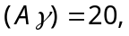  find the least and greatest possible values of (BC).
(b) Find the Fisher’s index number for the following data and show that it satisfies both the factor reversal test and time reversal test.
Commodity | Base Year |  | Current Year
Commodity | Price | Quantity | Price | Quantity
A | 10 | 25 | 12 | 30
B | 8 | 21 | 9 | 25
C | 4.5 | 28 | 6.5 | 35
D | 3.5 | 16 | 4 | 20
––——————
DE-4062
31
DISTANCE EDUCATION
B.Sc. DEGREE EXAMINATION, DECEMBER 2008.
Mathematics
ALGEBRA
Time : Three hours Maximum : 100 marks
Answer any FIVE questions.
(5 × 20 = 100)
1. (a) (i) Define symmetric difference of two sets of
 and 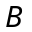 and show that 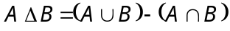.
(ii) If 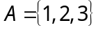, 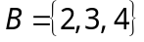, obtain the set 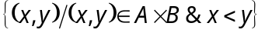.
(b) If and are equivalence relations defined on a set , prove that 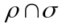 is also an equivalence relation.
2. (a) Prove that 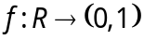 defined by 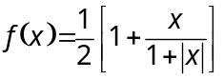 is a bisection.
(b) Let 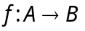 be a function. Let 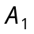 and 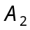 be two subsets of A and 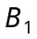 and 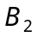 are subsets of B. Then prove that
(i) 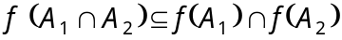.
(ii) 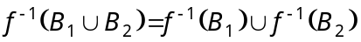.
3. (a) Let G be a group, show that the centre of G and the normalizer of an element of G are subgroups of G.
(b) Prove that a subgroup of a cyclic group is cyclic.
4. (a) State and prove Cayley’s theorem for a finite group.
(b) State and prove fundamental theorem of homomorphism.
5. (a) (i) Show that a non–empty subset S of a ring R is a subring iff 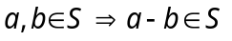 and 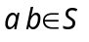.
(ii) Show that the intersection of two subrings of a ring R is a subring of R.
(b) If I is an ideal of a ring R with identity 1 and if 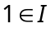, then show that 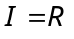. Show also that a field has no proper ideals.
6. (a) Let R and 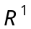 be rings and 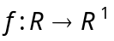 be a homomorphism show that
(i) 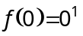
(ii) 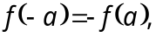 for all 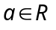
(iii) If R is a commutative ring then 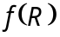 is commutative.
(b) Define principal ideal of a ring and show that every ideal of an Euclidean domain is a principal ideal.
7. (a) Define subspace of a vector space over a field F. Let V be a vector space over a field F. A non–empty subset W of V is a subspace of V iff  and 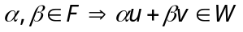.
(b) Let V be a finite dimensional vector space over a field F. Show that any linearly independent set of vectors in V is part of a basis.
8. (a) Let V be a finite dimensional vector space over a field F. Let A and B be subspaces of V. Then show that .
(b) Define an orthogonal set and orthogonal complement of a set.
Show that if S is any subset of an inner product space V, then 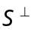 is a subspace of V.

—————————
32
DE-4063
DISTANCE EDUCATION
B.Sc. (Maths) DEGREE EXAMINATION, DECEMBER 2008.
OPERATIONS RESEARCH
Time : Three hours Maximum : 100 marks
Answer any FIVE questions.
Each question carries 20 marks.
1. (a) The manager of an oil refinery must decide on the optimum mix of 2 possible blending processes of which the inputs and outputs production run are as follows :
 | Input |  | Output
Process | Crude A | Crude B | Gasoline X | Gasoline Y
1 | 6 | 4 | 6 | 9
2 | 5 | 6 | 5 | 5
The maximum amounts available of Crudes A and B are 250 and 200 units respectively. Market demand shows that atleast 150 units of gasoline X and 130 units of gasoline Y must be produced. The profits per production run from process 1 and 2 are Rs. 4 and Rs. 5 respectively. Formulate the problem for maximising the profit.
(b) Find the maximum value of 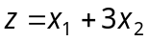
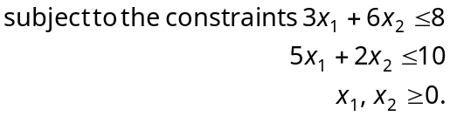
2 (a) State the duality theorem and write the dual of the linear programming problem :
Maximize 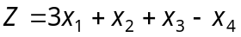
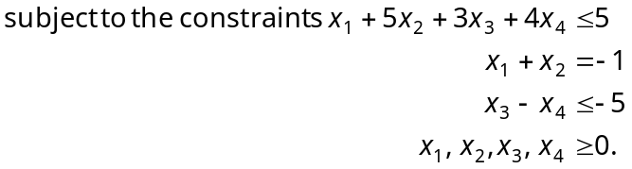
(b) Use penalty method to maximize 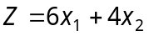
subject to the constraints
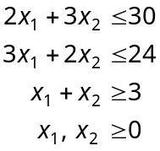
3. (a) Explain the two-phase method for solving a given linear programming problem.
(b) Use two phase simplex method to
Maximize 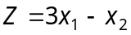
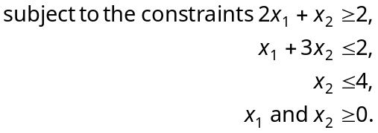
4. (a) What is integer linear programming? Explain.
(b) Find the optimum solution to the linear programming problem.
Maximize 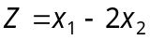
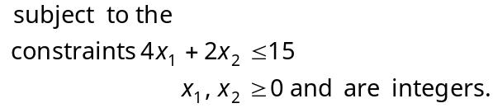
5. (a) Explain North-West Corner method to solve transportation problem for an initial basic feasible solution.
(b) Using Vogel's Approximation method, obtain an initial basic feasible solution of the following transportation problem :
 | D | E | F | G | Available
A | 11 | 13 | 17 | 14 | 250
B | 16 | 18 | 14 | 10 | 300
C | 21 | 24 | 13 | 10 | 400
Demand | 200 | 225 | 275 | 250
6. (a) Explain the nature of a travelling salesman problem and give its mathematical formulation.
(b) Solve the travelling salesman problem given by the following data :
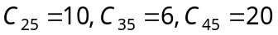 where 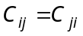 and there is no route between cities i and j if a value for 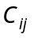 is not shown.
7. (a) Solve the game graphically
 |  | Player B
 |  | B₁ | B₂ | B₃ | B₄
Player A | A₁ | 2 | 1 | 0 | –2
Player A | A₂ | 1 | 0 | 3 | 2
(b) Using linear programming technique solve the game whose pay-off matrix is
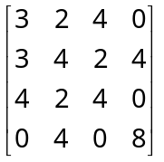
8. (a) Distinguish between PERT and CPM. What is a critical path?
(b) For the network given below, find the critical path and the probability of completing the project in 21 days.
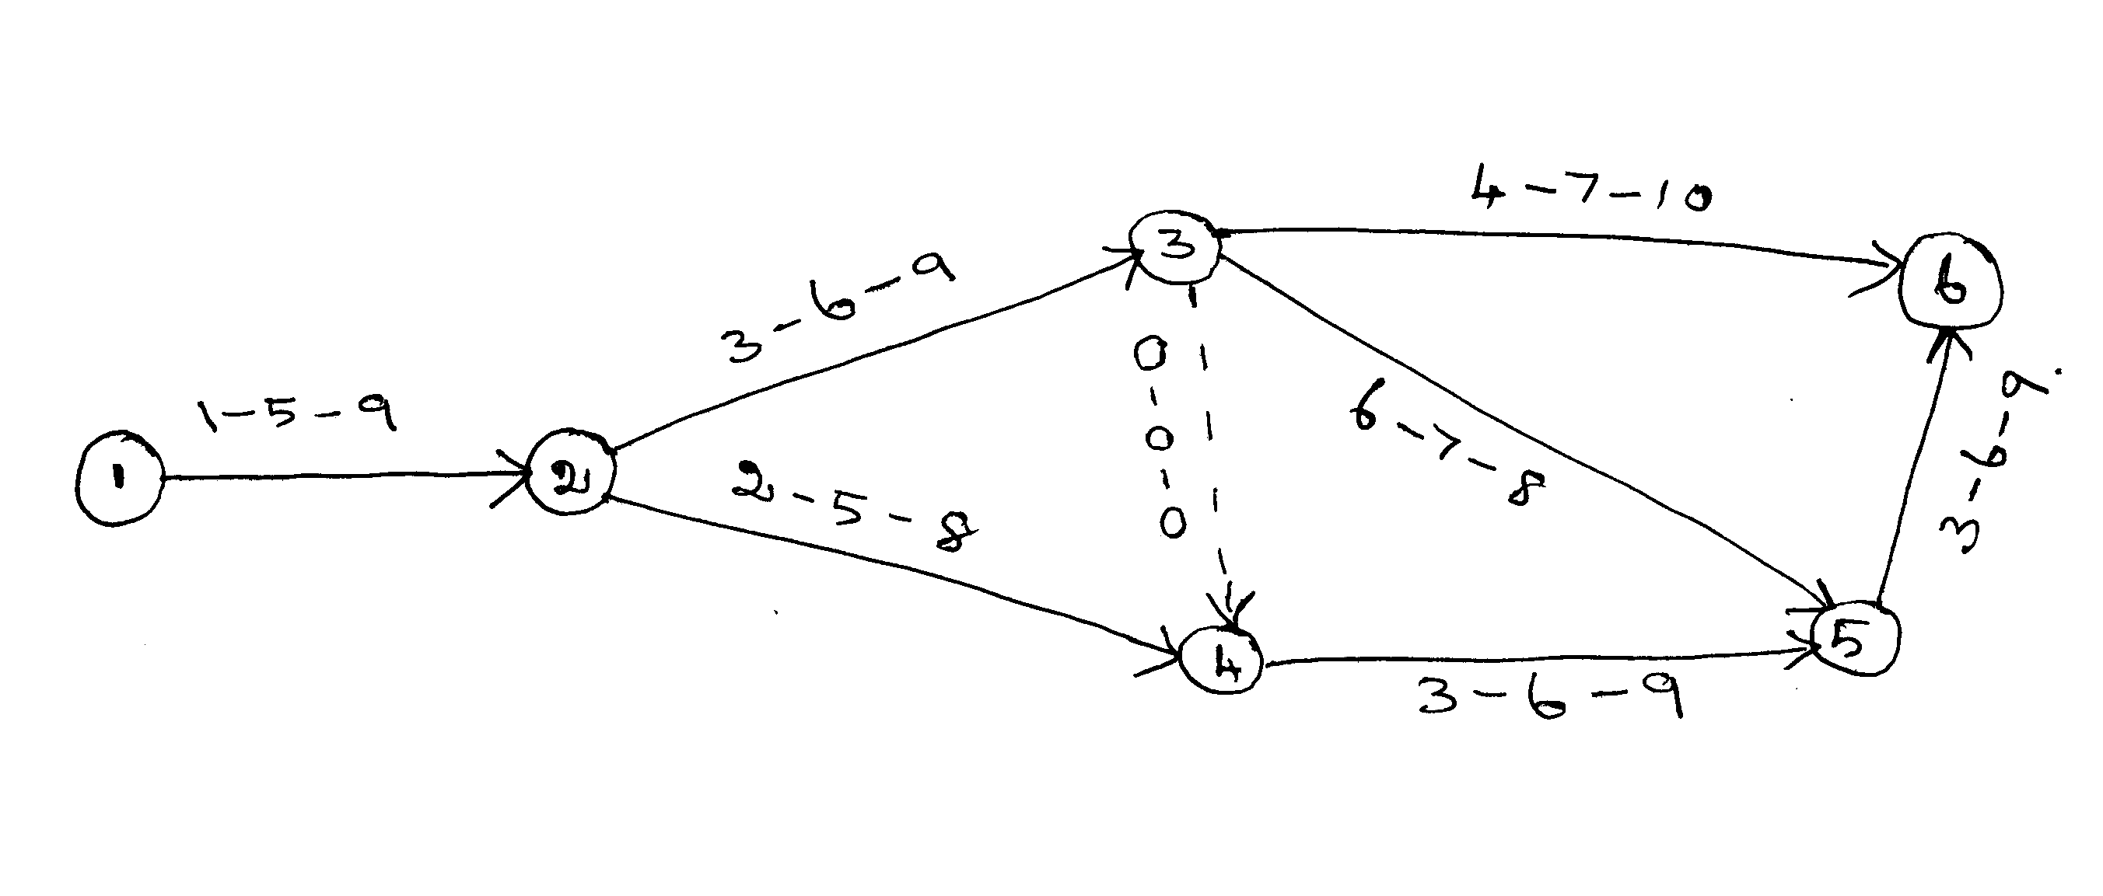
——————————
DE–4064
33
DISTANCE EDUCATION
B.Sc. (Mathematics) DEGREE EXAMINATION,
DECEMBER 2008.
NUMERICAL METHODS
Time : Three hours Maximum: 100 marks
Answer any FIVE questions.
All questions carry equal marks.
1. (a) Find the real root of 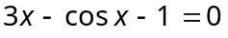 by Newton–Raphson method correct to four decimal places.
(b) Find the real root of the equation 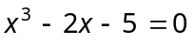 by the method of false position.
2. (a) Solve the equations :
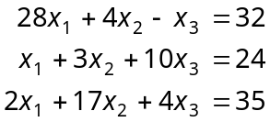
by Gauss elimination method.
(b) Explain Gauss–Jordan elimination method.
3. (a) Derive Lagrange’s interpolation formula.
(b) Use Bessel’s formula to find 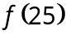, given :
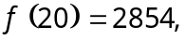 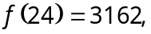 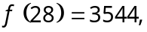 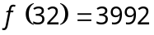.
4. (a) Find a polynomial of degree 4 which takes the values :
x : | 2 | 4 | 6 | 8 | 10
y : | 0 | 0 | 1 | 0 | 0
and hence find 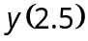.
(b) Find 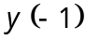 if 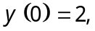 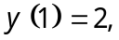 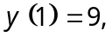 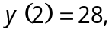 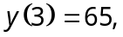 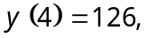 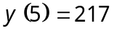.
5. (a) Evaluate 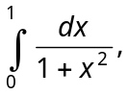 using trapezoidal rule with 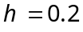. Hence determine the value of .
(b) From the following table, obtain the value of 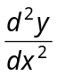 at the point 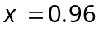.
x : | 0.96 | 0.98 | 1.00 | 1.02 | 1.04
f (x) : | 0.7825 | 0.7739 | 0.7651 | 0.7563 | 0.7473
6. (a) Derive Trapezoidal rule.
(b) Evaluate 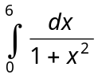 by using Weddle’s rule.
7. (a) Using Taylor series method find correct to four decimal places the value of 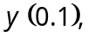 given 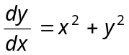 and 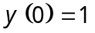.
(b) Solve 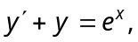 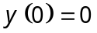 by Picard’s method.
8. (a) Solve numerically 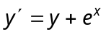, for 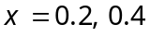 by improved Euler method.
(b) Apply the fourth order Runge-Kutta method to find 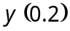 given that 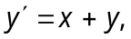 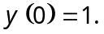
——————
DE–4065
34
DISTANCE EDUCATION
B.Sc. (Mathematics) DEGREE EXAMINATION,
DECEMBER 2008.
COMPLEX ANALYSIS
Time : Three hours Maximum : 100 marks
Answer any FIVE questions.
All questions carry equal marks.
(5 × 20 = 100)
1. (a) State and prove the sufficient conditions for the function 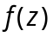 is to be analytic in Cartesian form.
(b) Prove that the function
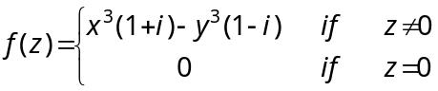
Satisfies C-R equation at Origin but 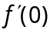 does not exist.
2. (a) (i) If 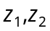 are complex numbers, show that 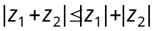.
(ii) Show that an analytic function with constant modulus is a constant.
(b) Prove that 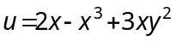 is harmonic and find its harmonic conjugate. Also find the corresponding analytic function.
3. (a) Find the bilinear transformation that maps 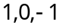 of the -plane and 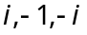 of the -plane.
(b) Show that any bilinear transformation can be expressed as a product of translation, rotation, magnification and inversion.
4. (a) Prove that a bilinear transformation transform the real axis into itself.
(b) Show that 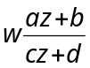 where 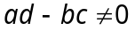 maps the real axis into itself if and only if a,b,c,d are real.
5. (a) State and prove Cauchy’s Integral formula.
(b) State and prove Maximum Modulus Theorem.
6. (a) Evaluate 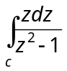 where c is a positively oriented circle 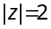.
(b) State and prove Morera’s theorem.
7. (a) State and prove Taylor’s theorem.
(b) Expand 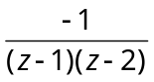 as a power series in z in the region 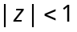.
8. (a) Prove that 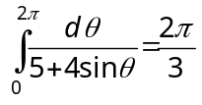.
(b) Prove that 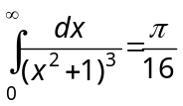.
————————
DE–4066
35
DISTANCE EDUCATION
B.Sc. (Mathematics) DEGREE EXAMINATION,
DECEMBER 2008.
DISCRETE MATHEMATICS
Time : Three hours Maximum : 100 marks
Answer any FIVE questions.
1. (a) Construct the truth table for the formula
(b) State which of them are tautologies.
(i) 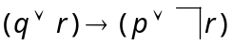
(ii) 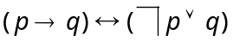
(c) Prove that 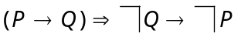.
2. (a) Establish
(b) Show that 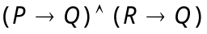 and 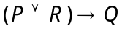 are equivalent formulae.
(c) Establish 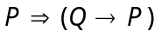.
3. (a) Write down the procedure to obtain a disjunctive normal form.
(b) Find PDNF for
(i) 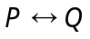
(ii) 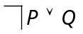
(c) Obtain the PDNF of 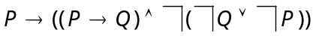.
4. (a) Show that is a valid statement
(b) Give the rules of generalization and specification.
(c) Verify the validity of the statement :
Lions are dangerous animals. These are lions. Therefore there are dangerous animals.
5. (a) Define sub graphs, spanning sub-graphs induced sub digraphs of a digraph G.
(b) Find whether the following graphs are isomorphic or not.
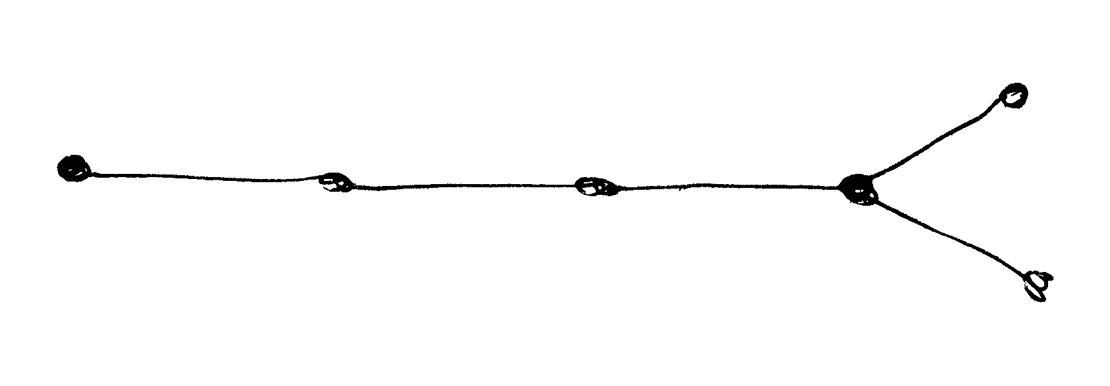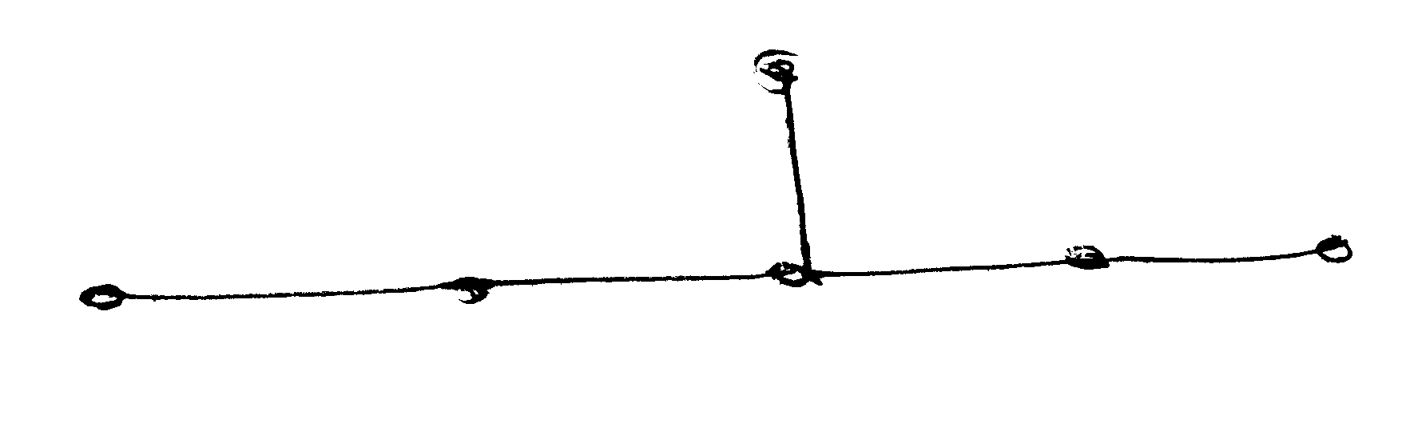
(c) Define :
(i) a complete graph
(ii) a bipartite graph
(iii) complete symmetric di graph with examples.
6. (a) Let G be a graph with n-vertices. Then prove that the following are equivalent.
(i) G is a tree
(ii) any two distinct vertices of G are joined by a unique path
(iii) G is a minimally connected
(iv) G is connected and has n – 1 edges
(v) G is a cyclic and has n –1 edges.
(b) Prove the Cayley’s formula : if 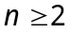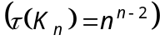
7. (a) Prove that if 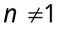 is a positive odd integer then the complete graph 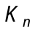contains 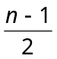 edge-disjoint Hamiltonian cycles.
(b) Prove that a given connected graph G is eulerian if and only if all vertices of G are of even degree.
8. (a) Prove that 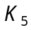 is not planar.
(b) Prove that 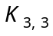 is non-planar
(c) State and prove Euler’s formula.
———————

